Team Hayagreeva – Technical Documentation
1.Project Overview
Pitch: A browser and messaging assistant that warns people about scams, fake links, and social engineering tricks before they click.
The Problem: Most scams work because fake messages and websites look completely real, so people click before realizing anything is wrong.
The Solution: A tool that scans links and messages in the background and warns the user in simple terms whenever something looks suspicious.
2. System Architecture & AI Pipeline

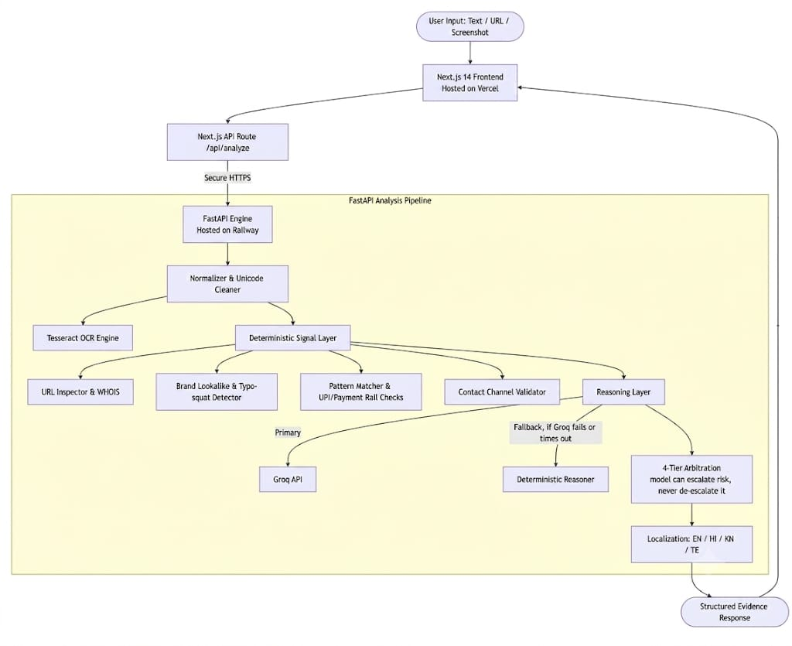

3. Tech Stack
- Languages: Python, TypeScript, JavaScript
- Frontend: Next.js 14, React, Tailwind CSS
- Backend: FastAPI, Uvicorn
- AI & Machine Learning: Groq Cloud API (LLM Inference), Tesseract OCR
- Deployment & Hosting: Vercel (Frontend), Railway (Backend)
- Libraries & Tools: Pydantic, Python-whois, Git
4. Future Scope & Hackathon Limitations
- Hackathon Constraints: External LLM calls introduce network latency; large image OCR uses lightweight cloud fallbacks for real-time speed.
- On-Device Small Language Models (SLMs): Fine-tune and deploy quantised models (e.g., Llama 3 / Gemma on-device) to eliminate external API reliance.
- Platform Integrations: Direct OS-level overlays and plugins for WhatsApp, Discord, Telegram, and native SMS clients.
5. Database & Data Structures
- Zero-Retention Model: User inputs, messages, and uploaded files are analysed in memory and immediately discarded rather than stored in a permanent database to protect user privacy.

- Lookup Tables & Sets for Fast Matching: Known malicious URLs, flagged keywords, and suspicious payment handles are held in preloaded hash sets for rapid $O\left(1\right)$ rule checking before calling heavier models.

- Structured JSON Response Schema: Output reports use a standardized JSON tree containing the risk level (Safe, Suspicious, Dangerous), confidence scores, localized reasoning, and detected threat tags.

